Accounting : Timesheet Review and Posting SOP

**Objective/Purpose/ Why:** Timesheet review by the accounting department provides assurance that the time reported is accurate and adheres to the company’s Employee Handbook and is properly approved by a supervisor.

Oversight of the timekeeping process by accounting personnel ensures that the timekeeping system is functioning as intended and that employees are using the system appropriately and segregation between the reporting and approval tasks meets internal control standards. The review by the accounting staff also provides a guarantee that the timekeeping process and reporting complies with all applicable laws, accounting standards and contract requirements.

The posting of timesheets in Deltek Vision by the Senior Accountant is performed as soon as the final review has been made and any necessary changes and corrections are completed. Posting records the number of hours worked by the employee by category and applies the wage and billing rates so that employees are accurately paid, and clients are billed correctly.

**Outcome:** Timesheets are required to be reviewed for accuracy and posted in Deltek Vision on a weekly basis as a prerequisite for paying employees on a biweekly schedule and billing clients for work performed. Management utilizes the data provided by posted timesheets to manage their projects and determine productivity and profitability, predict costs of future projects, allocate employee resources, and facilitate employee reviews. The Executive team uses this historical information to forecast and monitor the yearly operating budget, overall profitability of the company and for cash flow purposes.

**Process:** Following are the steps to take when reviewing and posting timesheets in Deltek Vision every Monday for the prior week ended on Sunday.

1. **REVIEWING TIMESHEETS IN VISION:**

* Timesheets should be completed and submitted for supervisor approval by Sunday evening. Timesheets should be approved by supervisors by 10:00 am on Monday.
* As early as possible on Monday morning, timesheets should be reviewed.

In the Time & Expense section, open “Timesheet”:

***SELECT EMPLOYEES:***

* Choose “Employees” in the toolbar under the “Timesheet” header, then “Select Employees”. In the “Labor Period Ending” dropdown, select the most recently ended payroll period.
* “Missing” timesheets - In the “Status Totals” section to the right of the pop-up deselect all types except “Missing”. For each employee missing a timesheet (indicating that no timesheet for the past week has yet been opened) send an email, and cc: Kim and Sheena, requesting they complete and submit their timesheet. The only employees who should have a missing timesheet are those that are active in Vision but are not required to submit timesheets. Maintain a list of the Missing timesheets so they can be reviewed when submitted.
* “In Progress” timesheets – Next select only the “In Progress” type and send emails to those employees listed requesting they finalize and submit their timesheet. Maintain a list of the In Progress timesheets so they can be reviewed when submitted.
* “Submitted” and “Approved” timesheets – Select both the Submitted and Approved timesheets and begin reviewing:

**Projects and Proposals**

* Task Name column – should have no “XX” or “Direct Expense”; proposals can have “Direct Labor”
* Labor Code column – should be populated
* No comment should be entered on projects, EGDV and PLDV (cell with time AND comment will be shaded blue). Comments can be entered on proposals.
* Any time spent on Quality Audits (might be posted to ADMIN-GEN) should be charged to the appropriate project. If the project or tasks are inactive, Sheena will re-open them to charge or move the time.

**PTO**

* Salaried employees can only post in 4- or 8-hour increments, unless approved by their supervisor.
* No PTO should be used for weekends.
* For salaried employees PTO should only be used to bring total hours as close to 40 hours per week as possible, but not less than 40 hours (e.g., if an employee has 38 hours without PTO, then only 4 hours of PTO should be posted to bring the total hours to 42).
* Should only use the comment provided in the dropdown (“1. PTO” or “PTO” with comment).
* Part-time employees and interns should have no PTO hours posted.

**HOLIDAY**

* Should only use the comment provided in the dropdown (“2. HOLIDAY”).
* Part-time employees and interns should have no HOLIDAY hours posted.

**ADMIN-GEN, CLIENT-GEN and PROPOSAL-GEN**

* Comments are required but should not be overly specific and should not use the term “marketing”; multiple comments are allowed.
* Any comment mentioning a specific client or pursuit should be searched for in Vision under **Info Center, Projects** to discover if a project/proposal number exists (begin with current year accounts) and, if so, then the employee should be requested to move their time to that account. If no project or proposal is found, then ask the Marketing Manager if a proposal number has been requested but not yet added to Vision.

Requested changes: If a revision is required, reclassify the timesheet from “Submitted” or “Approved” to “In Progress” by making a change in the record, removing the change, and selecting “Save”. Email the employee requesting the revision and ask them to notify their supervisor that the timesheet needs to be re-approved when they have made the revision.

***FLOOR CHECK:*** Once all timesheets have been submitted, approved, and reviewed (except for those listed under “Missing” as noted above) conduct a floor check for both full-time employees with less than 40 hours and part-time employees with less than expected hours, depending on their classification (interns may not meet their expected hours):

Regular Full-Time Employee: Fixed work schedule of 40 hours or more with full benefits (can be salaried/exempt or hourly/non-exempt).

*Salaried/Exempt*: Work schedule of generally 40 hours or more with full benefits.

*Hourly/Non-Exempt*: Work schedule of 30 hours or more with full benefits.

Review any timesheets with 44 hours or greater to ensure that no unnecessary PTO was posted (i.e., if the employee already has 40 or more hours of regular pay, there is no need to include PTO).

Regular Part-Time Employee: An employee who is scheduled to work less than 30 hours in a work week with no benefits, unless authorized.

Temporary Employee: Work schedule according to a specific need with no benefits, unless authorized.

See the ATG Employee Handbook for further information. (ADD LINK)

1. **PREPARING FOR POSTING IN VISION**:

* Verify all timesheets have been submitted and approved in the Timesheet module. If the supervisor is not available to approve their subordinates’ timesheet, contact their supervisor and request they approve it. Timesheets listed under “Missing” should only be for employees who are not currently active.
* Verify the prior week payroll has been posted by the Controller if last week was a payroll week.
* Verify all employee changes (terminations, raises, etc.) have been entered by Payroll staff.
* Verify A/R invoices and client checks have been posted with the Project Controller.

1. **POSTING TIMESEETS IN VISION:**

**Post Timesheet Transactions:**

► **TRANSACTION CENTER**

► **TRANSACTION POSTING**

* Timesheets – second tab (1.)
* Period Ending (2.) – at the dropdown choose the week to be posted
* Group (3.) – select each of the below groups individually:
* Admin
* Engineering
* Planning
* Select All (4.)
* Post (5.), Yes (Posting causes permanent changes to the database. Are you sure you want to post the selected files?), No (Would you like the posting log printed?)

Repeat for the other two groups. To verify everything is posted, choose “All Groups” and verify that no names are listed except for the zero-hour timesheets.

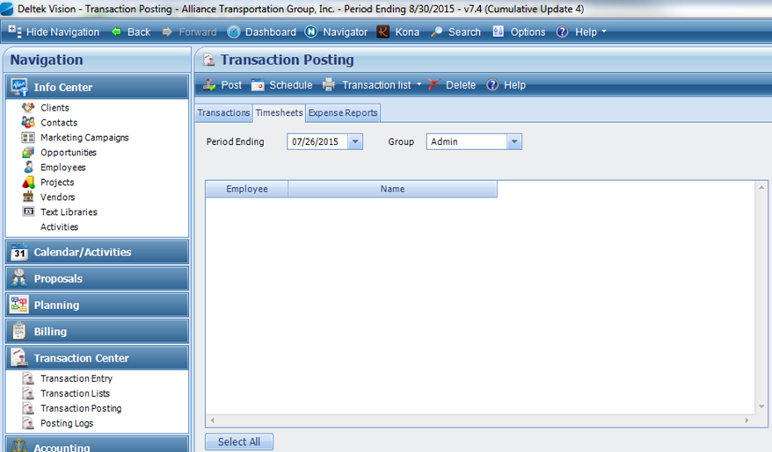

**1.**

**2.**

**3.**

**4.**

**5.**

**Run Adjust Salaried Job Cost:**

► **ACCOUNTING**

► **ADJUST SALARIED JOB COST**

* Select each posting entry individually (1.)
* Process (2.) then Yes (Adjusting salaried rates causes permanent changes to the database. Are you sure you want to adjust runs?) and that entry will disappear

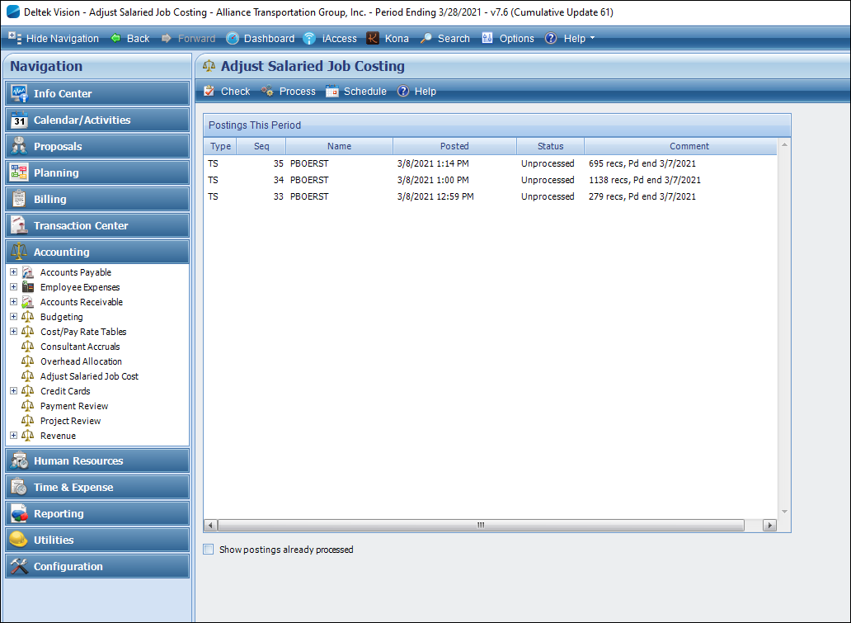

**1.**

**2.**

**Run Overhead Allocation**

► **ACCOUNTING**

► **OVERHEAD ALLOCATION**

* Verify the Range of Periods is for the current payroll month (1.), which should default to the current period.

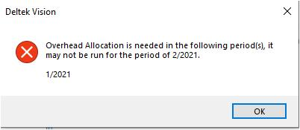Run (2.) then Yes (Are you sure you want to run Overhead Allocation for the period of mm/yyyy?)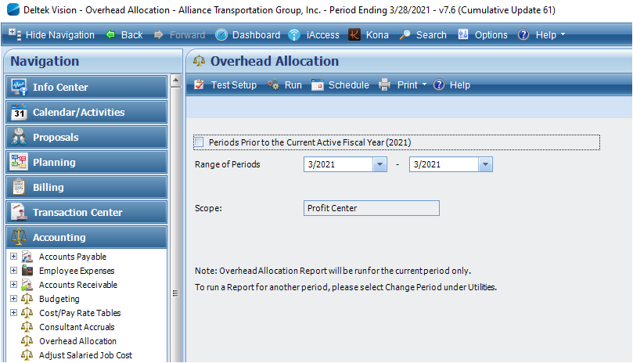

**1.**

**2.**

If the below message appears send a screenshot of the error to the Controller to resolve and respond back with their approval to proceed.

**Run Refresh Billing Extensions**

► **BILLING**

► **REFRESH BILLING EXTENSIONS**

* Saved Options (1.) – select “Current - Refresh Billing Extensions” from the dropdown if not already populated (if that option does not appear in the dropdown Gayle will grant access)
* Select Specific projects - will auto-fill when saved option is chosen
* Range of accounting periods from – from the dropdowns leave the beginning date as given (2.) and change the ending date to the current period (3.)
* Run (4.) then Yes (Are you sure you want to refresh Project Billing Extensions?)

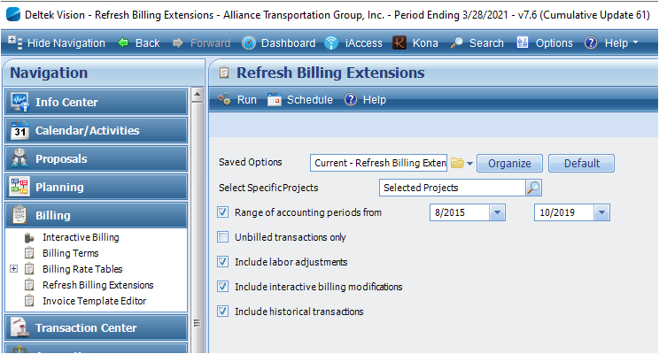

**1.**

**2.**

**3.**

**4.**

**Run Revenue Generation**

► **ACCOUNTING**

► **REVENUE**

► **REVENUE GENERATION**

* Saved Options (1.) – choose Rev Gen from the dropdown
* Select Specific Project (2.) – will default to Selected Projects
* All other fields will auto-fill
* Run (3.) then Yes (Are you sure you want to run Revenue Generation?)

**Run Revenue Generation**

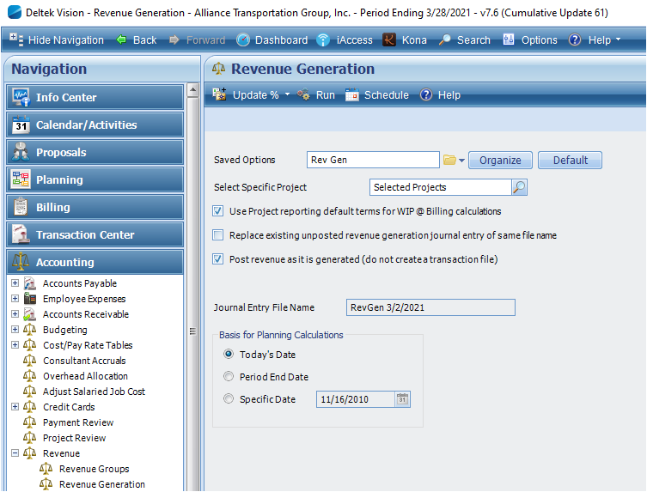

**2.**

**3.**

**1.**

► **ACCOUNTING**

► **REVENUE**

► **REVENUE GENERATION**

* Saved Options (1.) – choose Rev Gen from the dropdown
* Select Specific Project (2.) – will default to Selected Projects
* All other fields will auto-fill
* Run (3.) then Yes (Are you sure you want to run Revenue Generation?)

**Verify all Records have Posted**

► **TRANSACTION CENTER**

► **POSTING LOGS**

* Transaction Type (1.) – choose Timesheets from the dropdown
* Verify that a file for every Group is listed with the current date (2.)

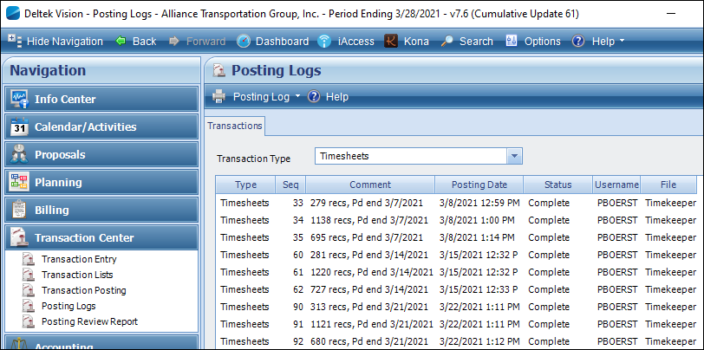

**1.**

**2.**

1. **SEND NOTIFICATION**:

* 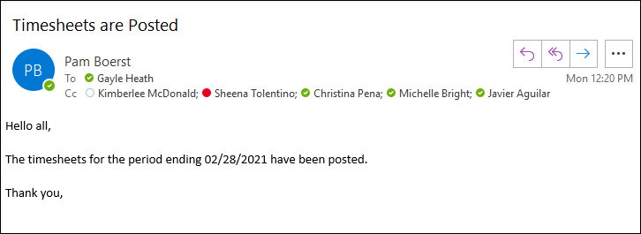Create a new email, copy all information from prior week’s email, update for current period and send.

**Subject Matter Experts:** General matters concerning timesheet review and posting, and operations performed in Deltek Vision should be directed to the Controller (Kim McDonald).

Questions regarding individual projects should be addressed by the Project Controller (Sheena Tolentino).

Questions involving time entered for proposals or any time entered in ADMIN-GEN, PROPOSAL-GEN, or CLIENT-GEN with comments that references a specific endeavor (e.g., “Bluebonnet Roadway pursuit”, etc.) should be addressed by the Marketing Manager (Ashley LaManna). Often a new proposal is in the process of being added to Vision Deltek or the employee is not aware that a proposal number has been created.

**Definitions:**

Exempt employee – an employee functioning at the level of an executive, administrative, professional, or outside salesperson (and certain computer employees) and are considered exempt from both minimum wage and overtime pay per the Fair Labor Standards Act (FLSA).

Non-exempt employee – an employee who is not exempt from the overtime provisions of the FLSA.

Posting – for timekeeping purposes it is the act of transferring labor costs from the accounting subledger (in this instance, the payroll subledger) to the general ledger so that it can be allocated to direct and indirect expenses and a payroll liability account.